##### A Project report on

**EXPENSE TRACKER**

###### A Dissertation submitted to JNTU Hyderabad in partial fulfillment of the academic requirements for the award of the degree.

**Bachelor of Technology**

**in**

**Computer Science and Engineering**

Submitted by

G. VIKAS REDDY 19H51A05N3

G. SHASHANK 19H51A05N2

B. SRINATH 19H51A05M8

Under the esteemed guidance of

A Deepika

(Assistant Professor)

**Department of Computer Science and Engineering**

**CMR COLLEGE OF ENGINEERING AND TECHNOLOGY**

(An Autonomous Institution under UGC & JNTUH, Approved by AICTE, Permanently Affiliated to JNTUH, Accredited by NBA.)

KANDLAKOYA, MEDCHAL ROAD, HYDERABAD - 501401.

#### 2019- 2023

**CMR COLLEGE OF ENGINEERING & TECHNOLOGY**

KANDLAKOYA, MEDCHAL ROAD, HYDERABAD – 501401

**DEPARTMENT OF COMPUTER SCIENCE AND ENGINEERING**

#### CERTIFICATE

This is to certify that the Mini Project-1 report entitled **"EXPEENSE TRACKER"** being submitted by **G. Vikas Reddy (19H51A05N3**), **G. Shashank (19H51A05N2), B. Srinath (19H51A05M8)**, in partial fulfillment for the award of **Bachelor of Technology in Computer Science and Engineering** is a record of Bonafide work carried out his/her under my guidance and supervision.

###### The results embody in this project report have not been submitted to any other University or Institute for the award of any Degree.

A.Deepika Dr. K Vijaya Kumar

Asst.Professor Professor and HOD

**Dept. Of CSE Dept. Of CSE**

Submitted for viva voice Examination held on ____________

**External Examiner**

**TABLE OF CONTENTS**

|  |  |  |  |
| --- | --- | --- | --- |
| **CHAPTER**  **NO.** | **TITLE** | | **PAGE NO.** |
|  | **LIST OF FIGURES** | | i |
|  | **LIST OF TABLES** | | ii |
|  | **ABSTRACT** | | iv |
| **1** | **INTRODUCTION** | | 1 |
|  | 1.1 | Need statement | 1 |
|  | 1.2 | Objective, Scope & Limitations | 1 |
|  |  | 1.2.1 Objective | 1 |
|  |  | 1.2.2 Scope | 2 |
|  |  | 1.2.3 Limitations | 2 |
| **2** | **BACKGROUND WORK** | | 3 |
|  | 2.1 | Introduction | 3 |
|  | 2.2 | Literature survey | 3 |
|  | 2.3 | Existing solutions | 4 |
| **3** | **PROPOSED SYSTEM** | | 7 |
|  | 3.1 | Introduction | 7 |
|  | 3.2 | Theoretical/ Conceptual framework | 7 |
|  |  | 3.2.1 Functional Requirements | 8 |
|  |  | 3.2.2 Non-functional Requirements | 8 |
|  |  | 3.2.3 Hardware Requirements | 8 |
|  |  | 3.2.4 Software Requirements | 9 |
|  | 3.3 | Advantages | 9 |
| **4** | **DESIGNING** | | 10 |
|  | 4.1 | Preliminary Design | 10 |
|  |  | 4.1.1 UML Diagrams | 10 |
|  |  | 4.1.2 ER Diagrams | 11 |
| **5** | **RESULTS AND DISCUSSION** | | 13 |
|  | 5.1 | Implementation | 13 |
|  | 5.2 | Result | 17 |
| **6** | **CONCLUSION AND FUTUREWORK** | | 19 |
| **7** | **REFERENCES** | | 20 |

CMRCET BTech(CSE) Page No i

## List of Figures

|  |  |  |  |
| --- | --- | --- | --- |
| **TABLE NO.** | **CHAPTER**  **NO.** | **TITLE** | **PAGE**  **NO.** |
| 1 | 3.2.2 | Theoretical/Conceptual Framework | 7 |
| 2 | 5.1.1 | Application Code | 13 |
| 3 | 5.1.2 | Infocard Code | 13 |
| 4 | 5.1.3 | Context Reduce code | 14 |
| 5 | 5.1.4 | Context code | 14 |
| 6 | 5.1.5 | Context Reducer code | 15 |
| 7 | 5.1.6 | Format Date code | 15 |
| 9 | 5.1.7 | Speechly code | 15 |
| 10 | 5.2.1 | Expense Tracker | 16 |
| 11 | 5.2.2 | Speechly API | 16 |

CMRCET B. Tech (CSE) Page No ii

# **List of Tables**

|  |  |  |  |
| --- | --- | --- | --- |
| **TABLE NO.** | **CHAPTER**  **NO.** | **TITLE** | **PAGE**  **NO.** |
| 1 | 4.1.1 | Use Case diagram | 9 |
| 2 | 4.1.2 | ER diagram | 10 |

CMRCET B. Tech (CSE) Page No iii

**ABSTRACT**

The name of our project is Expense Tracker. It is also called as money manager. It is a software that helps to keep an accurate record of your money inflow and outflow. We are building it using html, css, react and javascript languages. It is also voice powered by Speechly API. We can note our expense and income by this. It helps to track your financial progress. It is done by state management in React, Context API, Local Storage and Material UI.

CMRCET B. Tech (CSE) Page No iv

# **CHAPTER 1**

# **INTRODUCTION**

An Expense Tracker is a software or application that helps to keep an accurate record of your money inflow and outflow. Inflow means Income. Outflow means Expense. There can be many ways of income and expense. This expense tracker will manage everything related to money, that’s why it’s also called as money manager. This expense tracker is voice powered. It can be controlled by commands. It ultimately makes the person know how he earns and spends money. This can build some kind of discipline in usage of money. This reduces the chances of running out of money.

## Need Statement

In India many people are not able to manage money properly. So we want to introduce a voice powered expense tracker which is free of cost. This can make an impact on many lives. We have many expense trackers in use but none of them are free of cost and voice powered.

## 1.2 Objective, Scope & Limitation

## *1**.2.1 Objective*

* Many people in India live on a fixed income, and they find that towards the end of the month they don’t have sufficient money to meet their needs
* While this problem can arise due to low salary, invariably it is due to poor money management skills.
* People tend to overspend without realizing, and this can prove to be disastrous.
* This is one of the best ways to get your expenses under control and bring some semblance of order to your finances.

CMRCET B.Tech (CSE) Page No 1

## *1.2.2 Scope*

Our project mainly covers some operations like checking the balance, updating the balance (adding expense or income) , track history . We can perform these operations using voice commands.

## *1.2.3 Limitations*

###### There are many limitations for expense tracker.

###### It is time consuming.

###### It is a tiring task and hard to put under practice.

###### We need to report it time to time.

###### It is only in one language.

###### It can be only used for one currency.

###### We need to keep in check with tax regulations.

###### It is available only in one language and we can use this for only one currency.

CMRCET BTech (CSE) Page No 2

**CHAPTER 2**

**BACKGROUND WORK**

## 2.1 Introduction

This section discusses findings and observations done by some research works on voice powered expense tracker.

## 2.2 Literature survey

* Speechly is a developer of a voice command software designed to translate spoken words into actionable tasks. The company's software utilizes audio processing, speech recognition, natural language processing, and voice activity detection for command recognition. The API developed by Speechly is a streaming, spoken language understanding API that works to understand complex tasks with a multimodal interface available across platforms for use of voice in e-commerce, VR, gaming, digital health apps, and professional work

.

* Material Design is a design language developed by Google in 2014. Expanding on the "cards" that debuted in Google Now, Material Design uses more grid-based layouts, responsive animations and transitions, padding, and depth effects such as lighting and shadows. Google announced Material Design on June 25, 2014, at the 2014 Google I/O conference. The main purpose of Material Design is the creation of a new visual language that combines principles of good design with technical and scientific innovation. Designer Matías Duarte explained that, "unlike real paper, our digital material can expand and reform intelligently. Material has physical surfaces and edges. Seams and shadows provide meaning about what you can touch." Google states that their new design language is based on paper and ink but implementation takes place in an advanced manner.

CMRCET B. Tech (CSE) Page No 3

* React (also known as React.js or React JS) is a free and open-source front-end JavaScript library for building user interfaces based on UI components. It is maintained by Meta (formerly Facebook) and a community of individual developers and companies. React can be used as a base in the development of single-page or mobile applications. However, React is only concerned with state management and rendering that state to the DOM, so creating React applications usually requires the use of additional libraries for routing, as well as certain client-side functionality.

**2.3 Existing solutions**

There are many existing expense trackers. Every app has different features. A few existing solutions are

* Personal Capital
* Mint
* Fresh Books

CMRCET B. Tech (CSE) PageNo 4

**Personal Capital:**

Personal Capital is a full-featured investment manager for hire. It tracks and categorizes all the expenses you make on your credit or debit card. The app creates charts indicating your monthly cash flow. It has two versions: the free financial dashboard and the wealth management service. The wealth management option provides an investment management option, which functions as a robot advisor while providing live support. The free financial dashboard provides budgeting and a cash flow analyser. The app can also help you with retirement planning and provide an investment check-up.

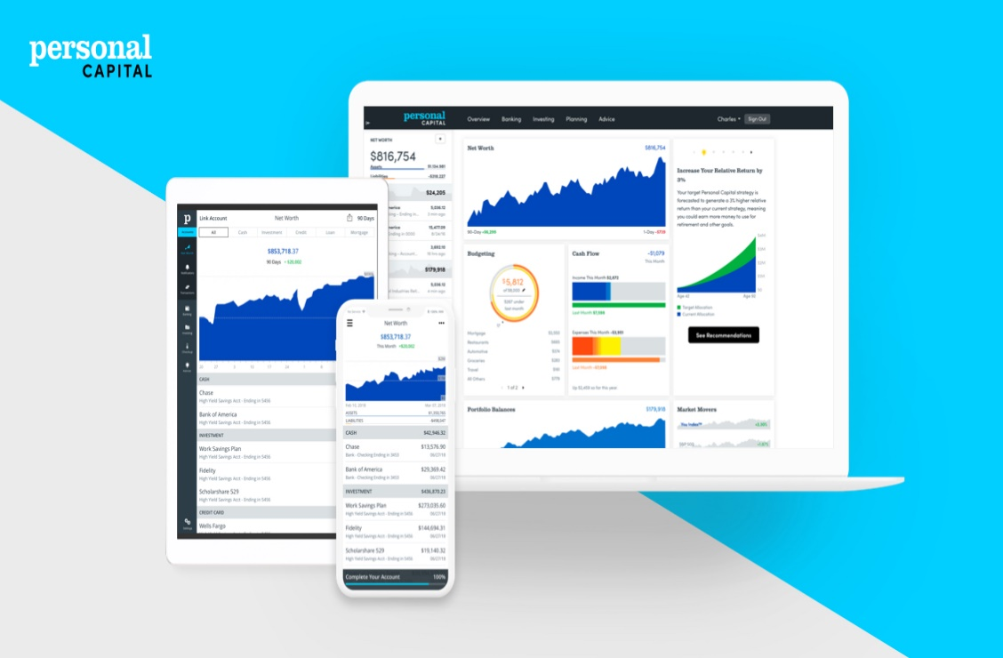

**Mint:**

Mint is one the best expense tracker apps known for personal finance tools – and a

great option for microbusinesses or side hustles. Mint is free, supports a wide range

of banks and lenders, and helps in expensive tracking, bills and credit monitoring,

CMRCET B. Tech (CSE) PageNo 5

and budgeting. It's available on iOS and Android.



**Fresh Books:**

Fresh Books is a comprehensive cloud-based accounting program that starts at $7.50a month for a single user and five clients. This plan allows an unlimited number of clients and an extra staff member, and it offers several useful project management tools. Making it a good option for entrepreneurs who want a fully functional accounting Package.

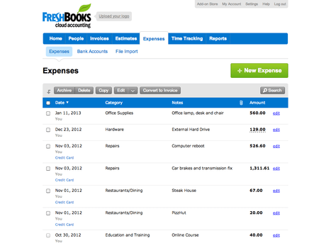

CMRCET B. Tech (CSE) Page No 6

**CHAPTER 3**

**PROPOSED SYSTEM**

## *3.1 Introduction*

This section presents the research methodology used in the study, the research design, and the data collection process.

*3.2 Theoretical/ Conceptual Framework*



Fig 3.2.2

The article explores the various steps in the process of providing voice powered software and expense tracker applications reference, as well as issues involved in providing such service at each step. The purpose of this exploration is twofold: First, this article presents some open research questions at each step in the process of providing expense tracker web applications. Second, the entire process of providing voice powered API’s reference is viewed as a whole, and a model of the provision of expense tracker reference service is developed at a high level of abstraction. It is hoped that this model may serve as a conceptual framework for future discussions of and development of applications for voice powered expense tracker.

CMRCET B. Tech (CSE) Page No 7

## *3.2.1 Functional Requirements and Non-Functional Requirements*

**2.3.1 Functional Requirements**

1.Dashboard panel

2.Add bill

3.Expense tracker

4.Expense planner

## *3.2.2 Non-functional Requirements*

1.Usability

2.Reliability

3.Performance

4.Availability

## *3.2.3 Hardware Requirements*

Desktop, Laptop and smart phone.

## *3.2.4* Software Requirements

Software Requirements specifies the logical characteristics of each interface and software components of the system.HTML, CSS are used for the front end designing and JavaScript for client side and server-side validation. VS Code is used as text editor. Node.js is used for javascript purpose and for backend we used react.js.

CMRCET B. Tech (CSE) Page No 8

## 3.3 ADVANTAGES

* Prioritize your spending.
* Become aware of poor spending habits.
* Take control of your finances.
* Better spending awareness.
* No more money loss.

CMRCET B. Tech (CSE) Page No 9

## CHAPTER 4

## DESIGNING

## 4.1 Preliminary design

Tools, which assist in preliminary design process, are UML Diagrams and ER diagrams.

## *4.1.1 UML Diagrams*

1. Use-case Diagram:

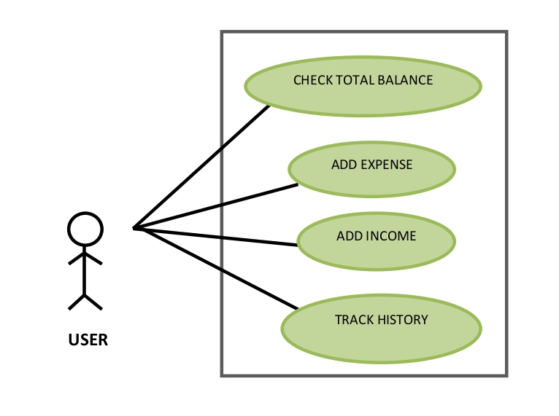

CMRCET B. Tech(CSE) PageNo 10

## 4.1.2 ER Diagram

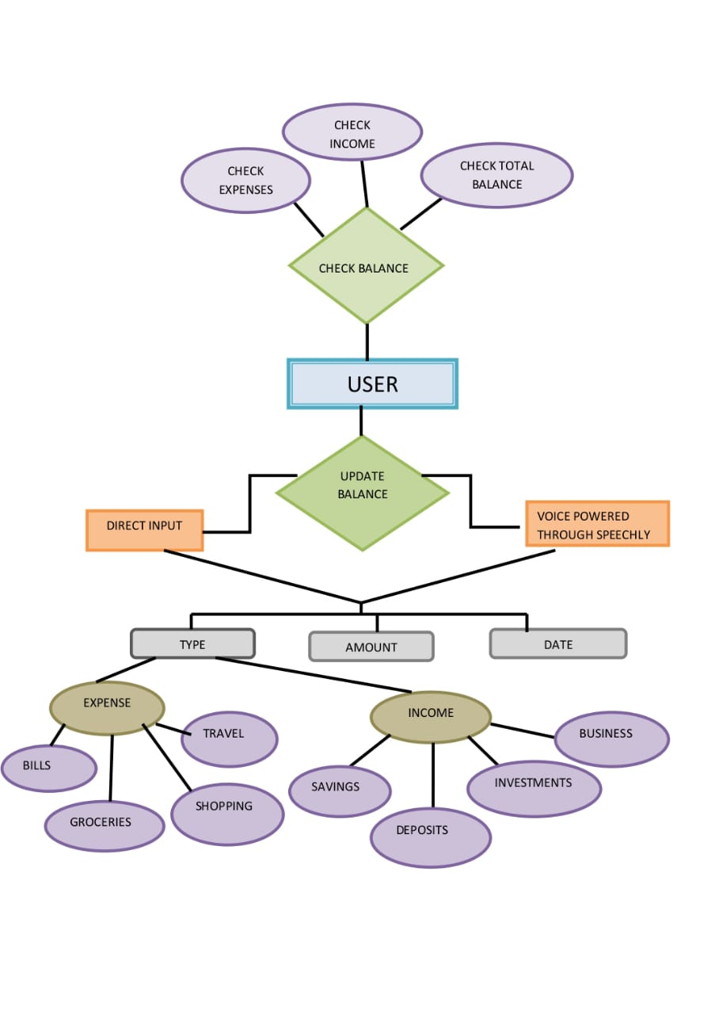

CMRCET B. Tech(CSE) PageNo 11

## 

## CHAPTER 5

## RESULTS AND DISCUSSION

**5.1 Implementation**

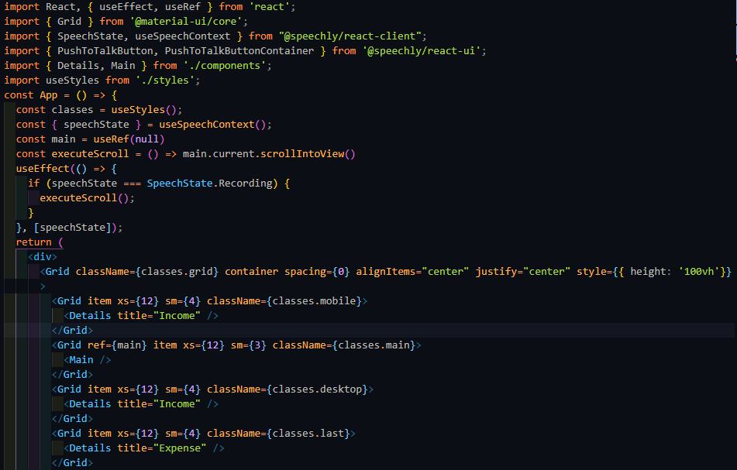

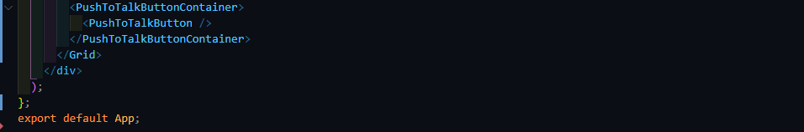Application code

CMRCET B. Tech (CSE) Page No 12

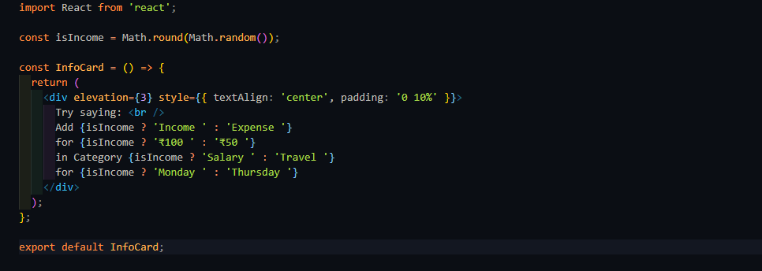

Infocard code

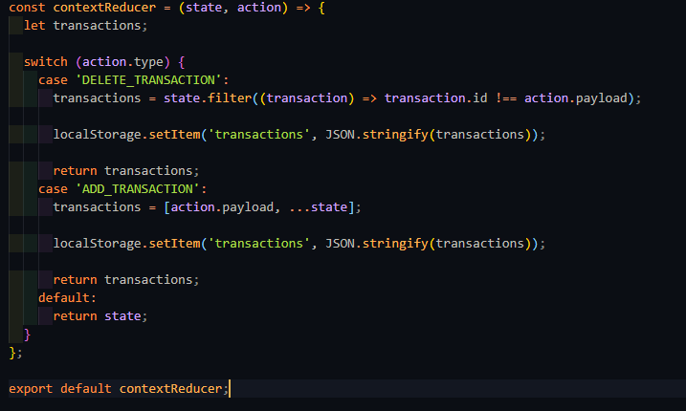

Context Reduce code

CMRCET B. Tech (CSE) Page No 13

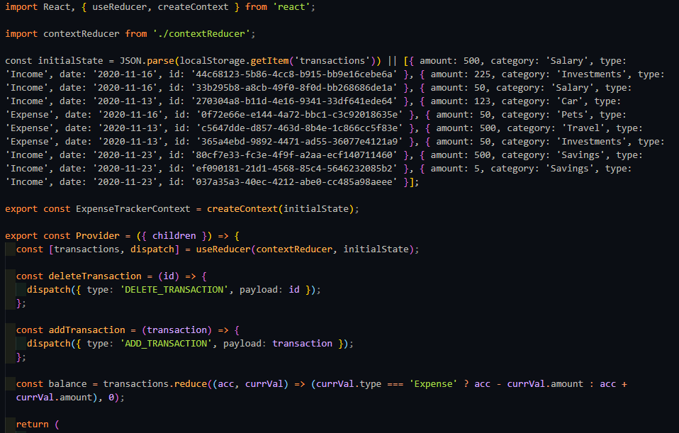

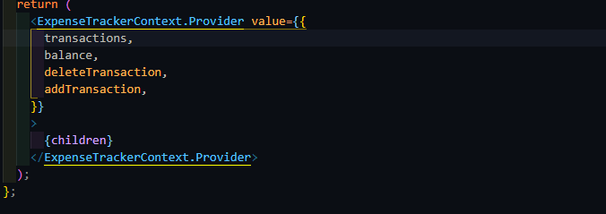

Context code

CMRCET B. Tech (CSE) Page No 14

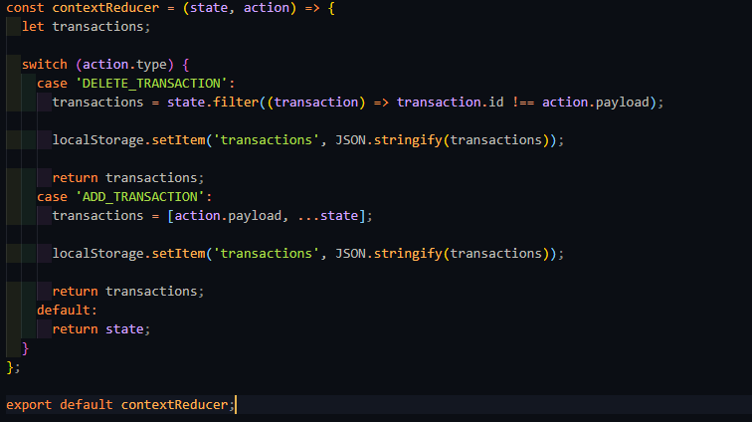

Context Reducer code

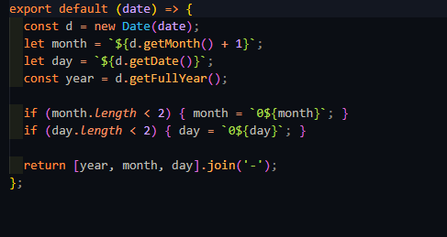

Format Date code

CMRCET B. Tech (CSE) Page No 15

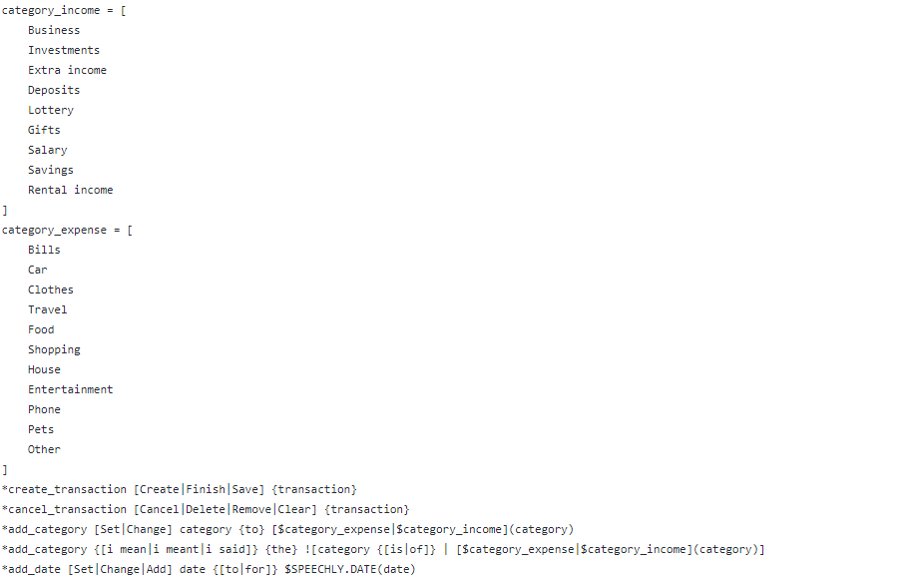

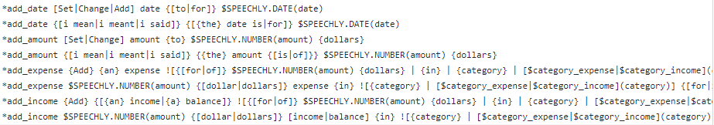

Speechly configuration

CMRCET B. Tech (CSE) Page No 16

**5.2 Result**

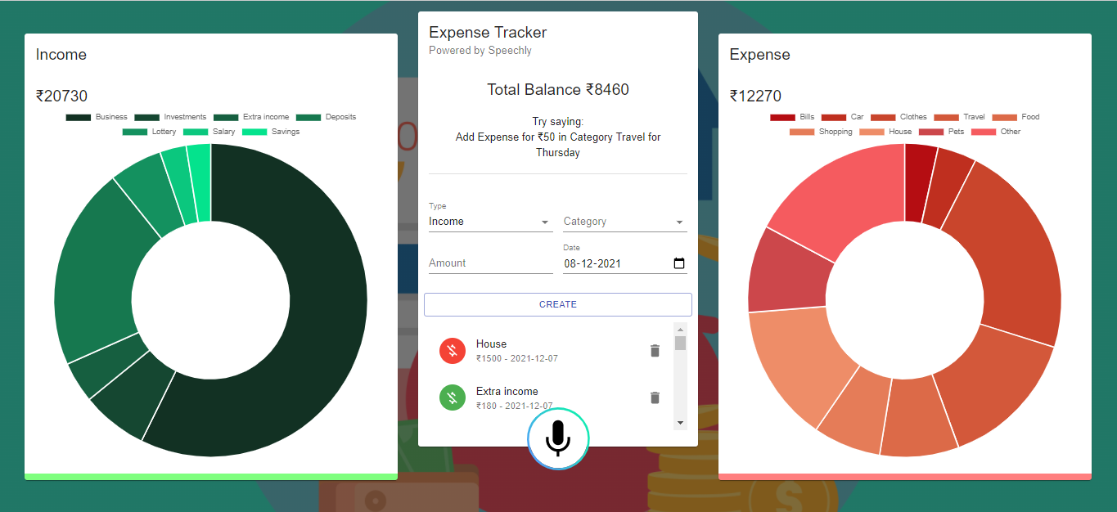

Expense Tracker

CMRCET B. Tech(CSE) Page No 17

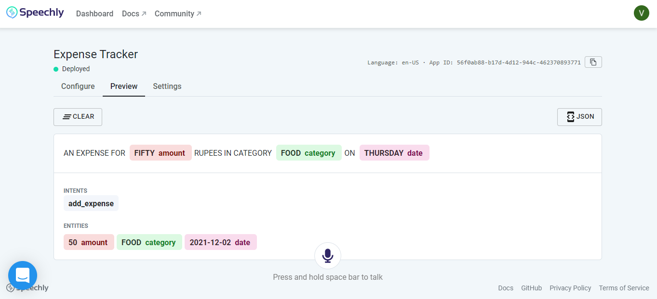

Speechly API

CMRCET B. Tech (CSE) Page No 18

## CHAPTER 6

## CONCLUSION AND FUTURE WORK

### 6.1 Conclusions

Hence, we developed a voice based expense tracker. It works both on direct text and voice command. It has user friendly graphical user interface. User can check or update his balance in it.

### 6.1 Future works

In future we can improve this software by connecting it to bank accounts. We can further add different languages and different currencies to our application so that people can feel more comfortable to use it. We can even add some warning if the user is going to become bankrupt. In future we can even track the person so that this software can also be used as remainder.

CMRCET B. Tech(CSE) Page No 19

## REFERENCES

* <https://expense-manager.com/>
* <https://au.linkedin.com/company/expense-manager/>
* <https://github.com/bradtraversy/expense-tracker-mern>
* <https://github.com/bradtraversy/expense-tracker-react>
* <https://www.speechly.com/>
* <https://morioh.com/p/44b3fcad04f3>

CMRCET B. Tech(CSE) Page No 20